

Task 4 – Pass Submission

Student Name: Truong Ngoc Gia Hieu
Student Number (Vietnam/Australia): SWS01217/105565520

Task Pass4a
In the first task of the Pass section, following the provided example of the EMPLOYEE and BRANCH relational schema, students are required to construct a corresponding relational schema based on the ERD between the CAMPAIGN and PLAYER entities, clearly indicating all primary and foreign keys.
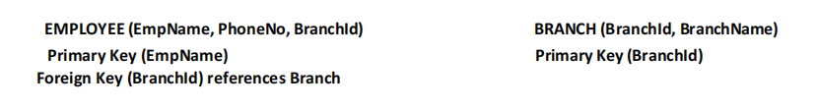
Figure 1: Example of Employee and Branch Relational Schema.

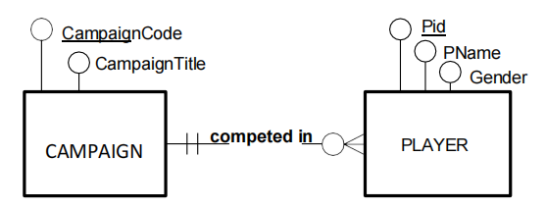
Figure 2: Entity-Relationship Diagram for Campaign and Player Entities.
Figure 3: Relational Schema for Campaign and Player Entities.

Task Pass4b
Before creating the two following tables named Campaign5520 and Player5520, I have to check what tables have already been created in iSQL Junior by using the command ‘show tables;’.
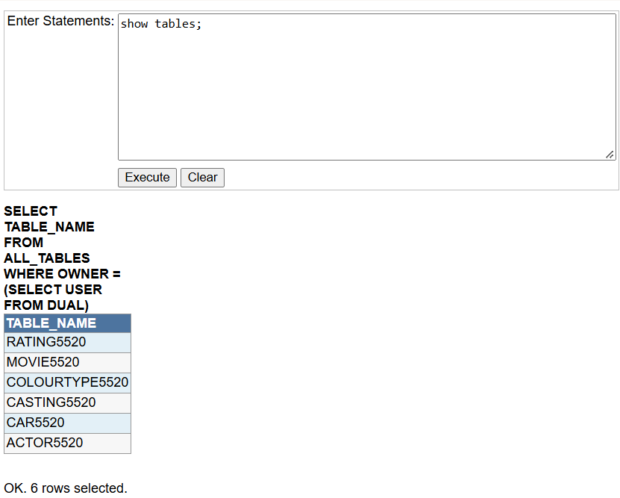
Figure 4: Checking Existing Tables in iSQL Junior.
Then, I created the Campaign5520 and Player5520 tables respectively.
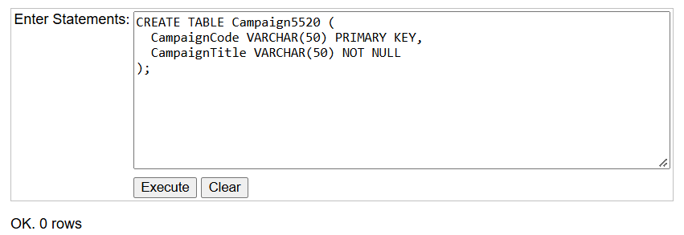
Figure 5: SQL Statement and Execution Result for Creating Campaign5520 Table.

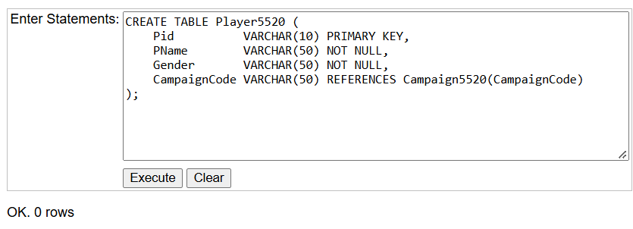
Figure 6: SQL Statement and Execution Result for Creating Player5520 Table.

Task Pass4c
In the third task, I have to insert values into the Campaign5520 and Player5520 tables based on the provided data. However, I need to check again to ensure that both tables have already been created in iSQL Junior by using command ‘show tables;’.
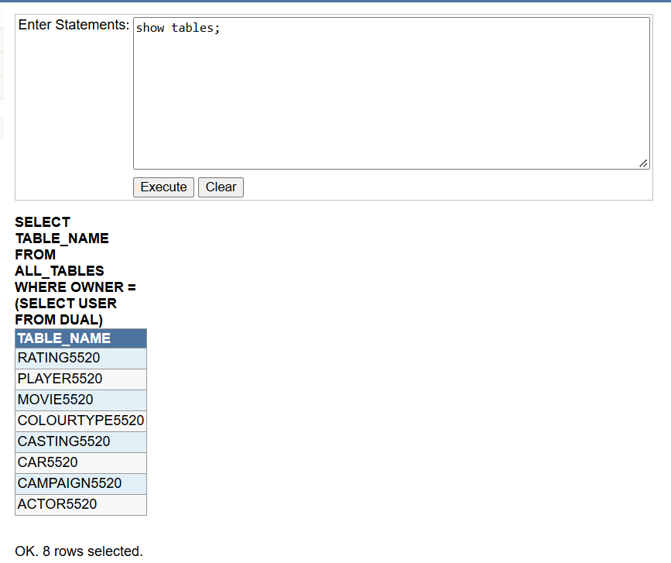
Figure 7: Table List Verification.
Notably, the iSQL Junior website allows me to insert data row by row, so I can just load the records sequentially.
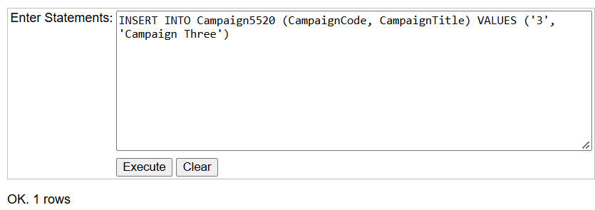
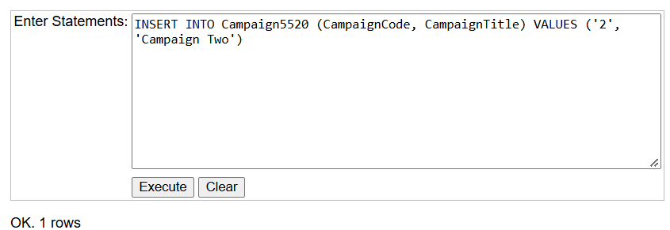
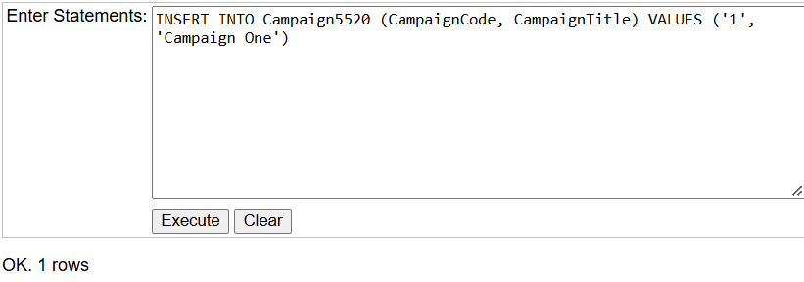
Figure 8: Inserting Data into the Campaign5520 Table.
After inserting all values into the table Campaign5520, I used the command ‘SELECT * FROM Campaign5520’ to display all records in the table.
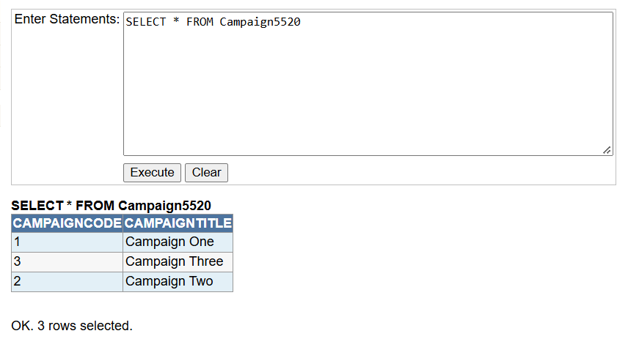
Figure 9: Verification of Inserted Data in Campaign5520 Table.
Next, I inserted sample data into the Player5520 table based on the description.
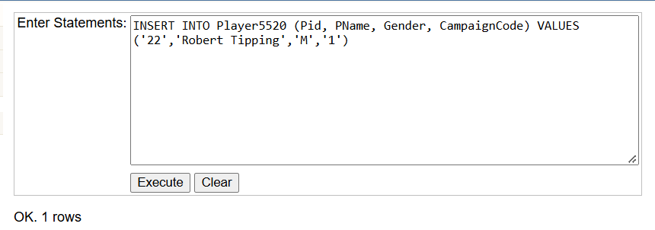
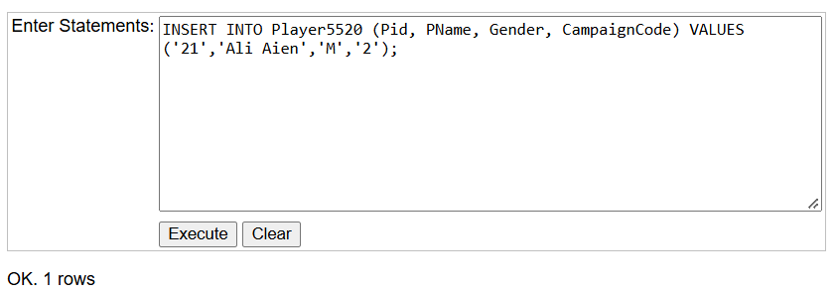
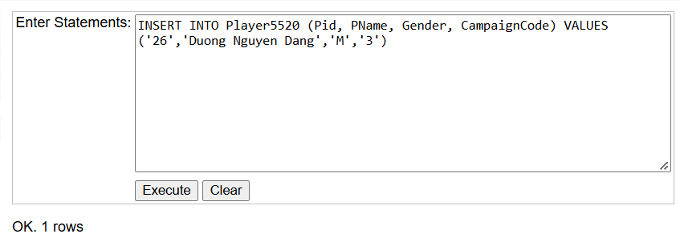
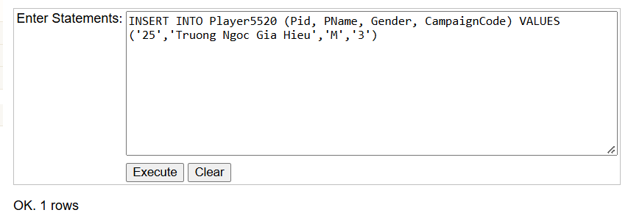
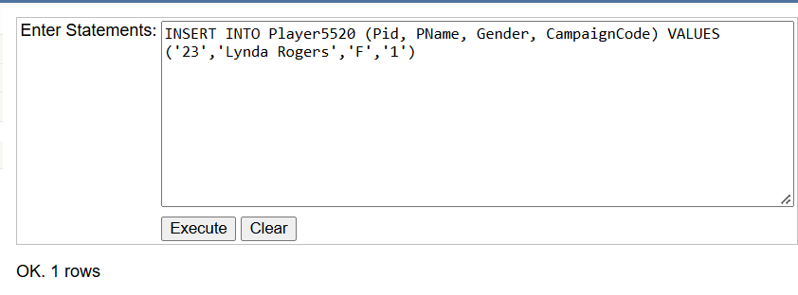
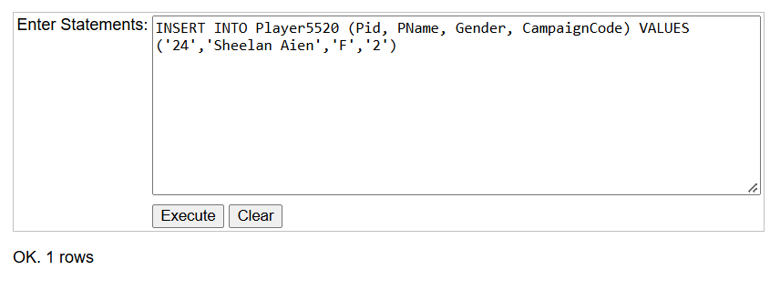
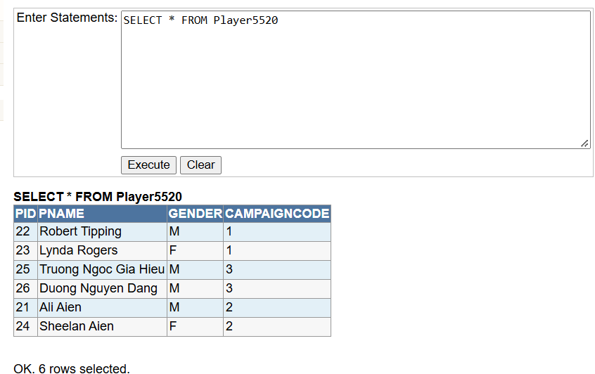
Similarly, I used the command ‘SELECT * FROM Player5520’ to display all records in the table.
Figure 10: Inserting Data into the Player5520 table.
Figure 11: Verification of Inserted Data in Player5520 Table.

Task Pass4d
Subsequently, in the next sub-task of the Pass submission, the task requires me to use the following commands for the Campaign5520 and Player5520 tables: ‘DESCRIBE Campaign5520’, ‘SELECT * FROM Campaign5520’, ‘DESCRIBE Player5520’, and ‘SELECT * FROM Player5520’.

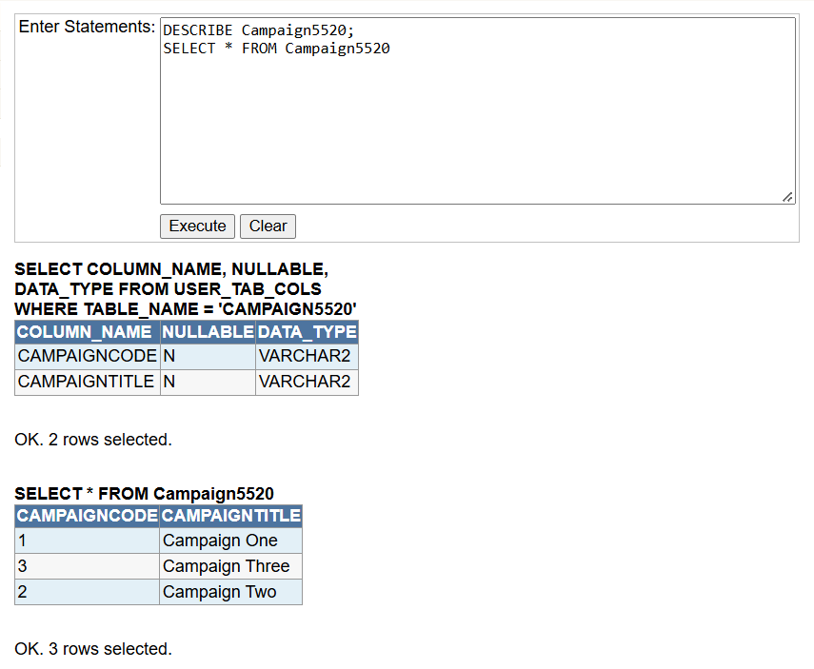
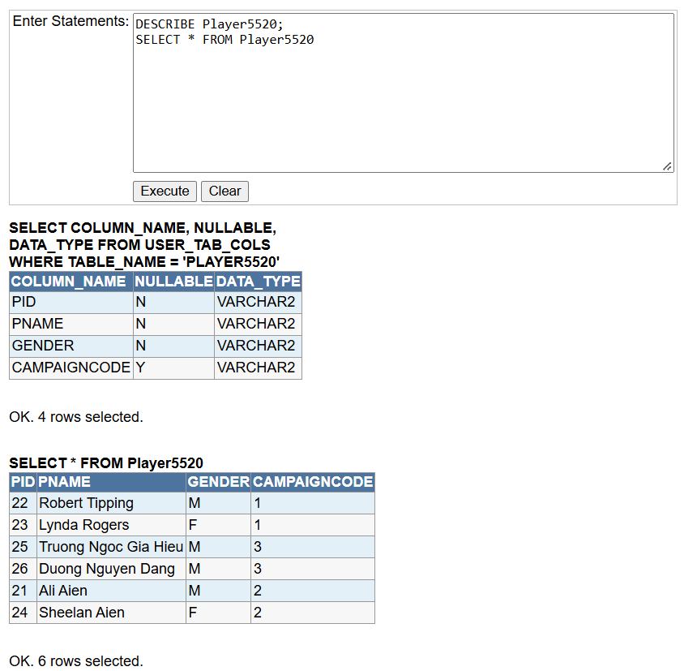
Figure 12: Structure and Contents of Campaign5520 and Player5520 Table.

Task Pass4e
In task Pass4e, first and foremost, I tried to insert a new record into the Campaign5520 table by using the command 'INSERT INTO Campaign5520 (CampaignCode, CampaignTitle) VALUES ('1', 'Campaign Four')'.
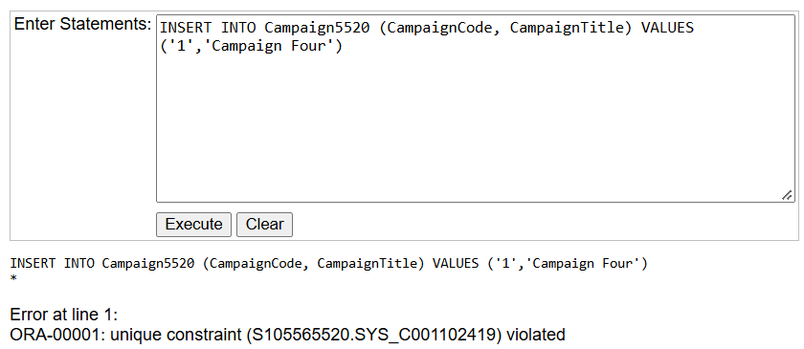
Figure 13: Unique Constraint Violation Error on Campaign5520 Table.

Based on the characteristics of a Primary Key which requires values to be unique, non-null, immutable, restricted to a single primary key per table, supported by automatic indexing, and able to serve as a foreign key reference, the statement resulted in an error when executed. Therefore, in the previous section, a record with CampaignCode = '1' (‘1,’,'Campaign One') had already been inserted.
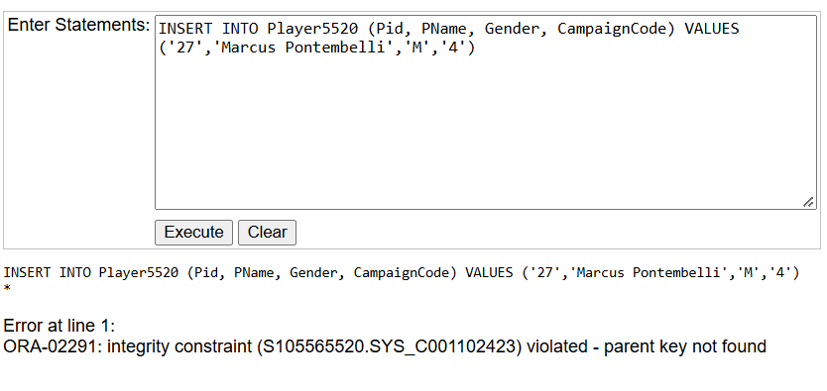
Next, I tried to insert a new record into the Player5520 table using the following command: 'INSERT INTO Player5520 (Pid, PName, Gender, CampaignCode) VALUES ('27', 'Marcus Pontembelli', 'M', '4')'.
It can be seen from Figure 14 that when executed, the website returns an error because the CampaignCode value '4' does not exist in the parent table (Campaign5520). According to the foreign key constraint defined in the schema, a child record cannot reference a primary key value that is missing from the parent table, thereby triggering the ORA-02291 integrity constraint violation (parent key not found).
Figure 14: Foreign Key Integrity Constraint Violation Error on Player5520 Table.
Then, I tried to execute the command 'DELETE FROM Campaign5520 WHERE CampaignCode = '2'', as specified in the description.
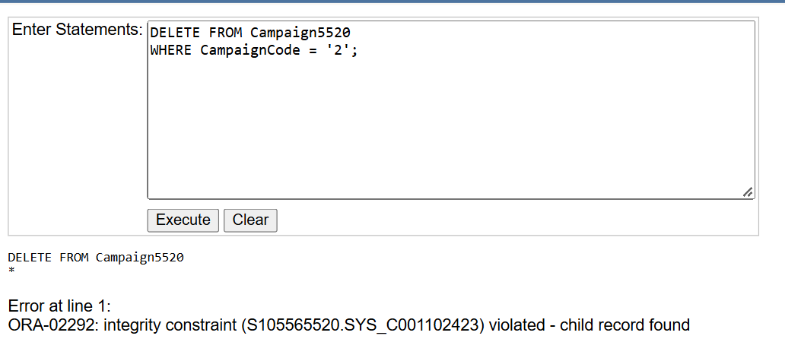
Figure 15: Foreign Key Constraint Violation Error when Deleting Parent Record.
It is clear that the DELETE statement failed with an error because the record being removed (CampaignCode = '2') is still actively referenced by child records in the Player5520 table. In terms of maintaining referential integrity, Oracle prevents the deletion of a parent key as long as dependent child rows exist.

Task Pass4f
According to the description of Task Pass4f, I have to write a single SQL statement that lists the player name and campaign title for every row in the Player5520 table.
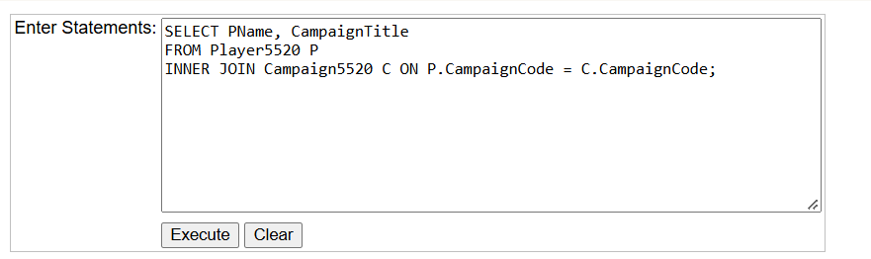
Figure 16: SQL Statement for INNER JOIN Query on Player5520 and Campaign5520 Tables.
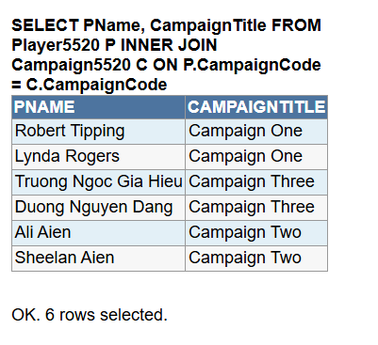
Figure 17: Table Result Showing Joined Data from Player5520 and Campaign5520.

Task Pass4g
Next, I have to write a single SQL statement that counts the number of rows in the Player table.
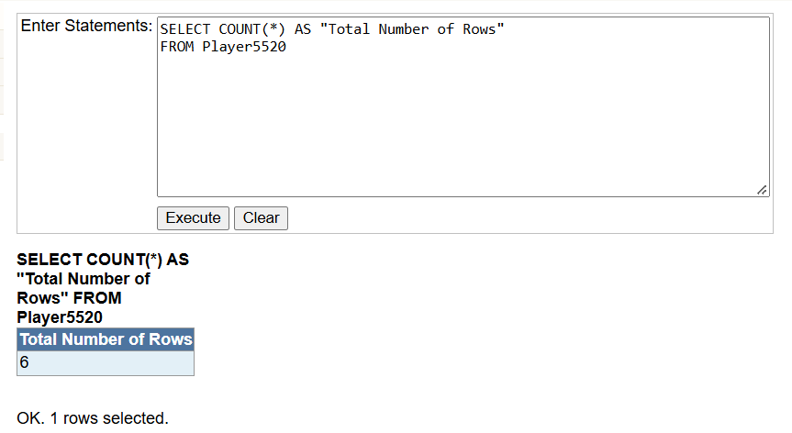
Figure 18: SQL Statement and Execution Result for Counting Total Rows in Player5520 Table.

Then, I have to write a single SQL statement that counts the number of rows grouped by CampaignCode in the Player5520 table.

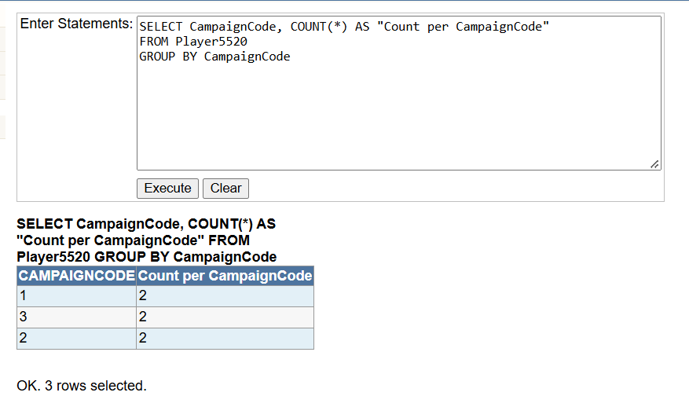
Figure 19: SQL Statement and Execution Result for Grouping and Counting Records by CampaignCode.

Task Pass4h
Based on the description of Task Pass4h, I opened the file named moviedatabaseDAD in Microsoft Access and then changed the table names, for instance, from MOVIE2833 to MOVIE5520, and similarly for the other tables.
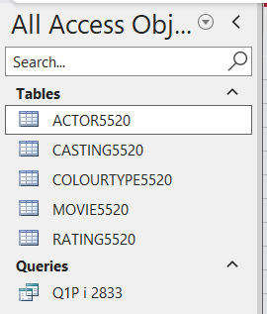
Next, as specified in Task Pass4h, I created a new Query Design named Task Pass4h in Microsoft Access, clicked on the SQL icon at the bottom right of the screen, and executed a single SQL statement (‘SELECT BirthCountry, COUNT(*) AS ActorCount FROM ACTOR5520 GROUP BY BirthCountry;’) to count the number of rows grouped by BirthCountry in the ACTOR5520 table. Finally, I derived a visual graph from the query results to effectively present and compare the distribution of actors across various countries, for instance, displaying higher concentrations in countries such as the USA compared to Germany.
Figure 20: Renamed Tables in Microsoft Access for Task Pass4h.

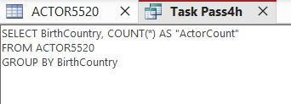
Figure 21: SQL Statement in Microsoft Access to Count Actors by BirthCountry.

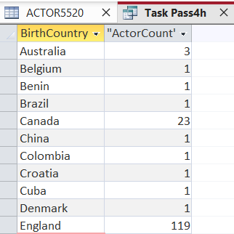

Figure 22: Query Execution Result Displaying Actor Counts Grouped by BirthCountry.

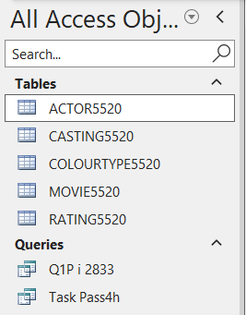
Figure 23: Navigation Pane Displaying Saved Query 'Task Pass4h' in Microsoft Access.

Task Pass4i
In the task Pass4i, students are self-created to design a new query named Task Pass4i in Microsoft Access; specifically, by clicking on the SQL icon at the bottom right of the screen, I wrote a single SQL statement to retrieve specific columns (MovieTitle, Runtime, and RatingCode) from the MOVIE5520 table. Therefore, the query filters movies for a limited range of runtimes (between 125 and 150 minutes) and a limited list of rating codes (for instance, 'G' and ‘PG’), with the final displayed results systematically sorted in alphabetical order by movie title sequence.
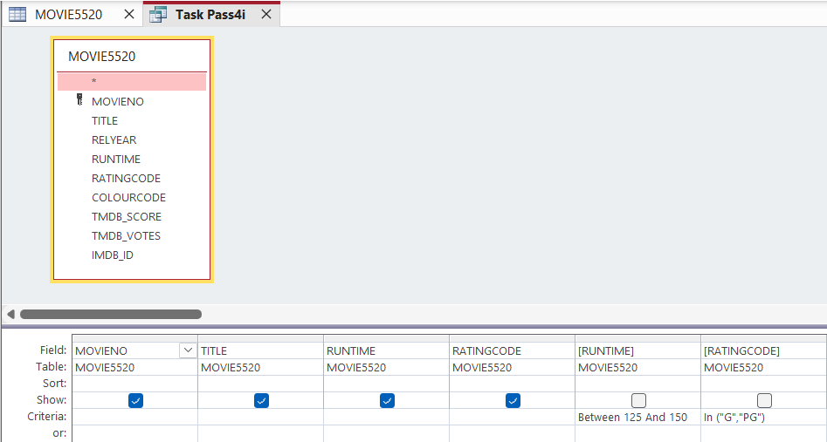
Figure 24: Query Design View with Criteria Filters for Task Pass4i.

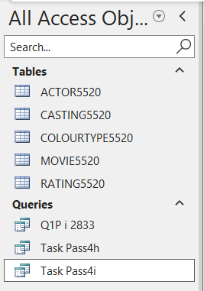
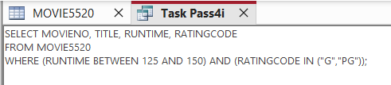
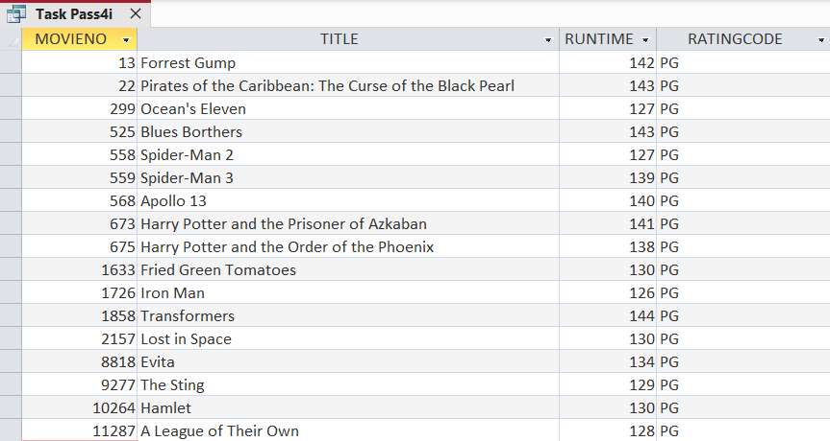
Figure 25: SQL View with Criteria Filters for Task Pass4i.
Figure 26: Query Execution Result Displaying Filtered Movies for Task Pass4i.
Figure 27: Navigation Pane Displaying Saved Query 'Task Pass4i' in Microsoft Access.

Task Pass4j
In Task Pass4j, students are provided with a scenario describing the operations of the 'SwinEats' food delivery platform. Specifically, each delivery job requires a single driver and is defined by key attributes, such as a job ID, title, duration (in hours), and description. Meanwhile, drivers are identified by their name, address, and mobile phone number.
Furthermore, the business domain permits a driver to perform multiple delivery jobs; conversely, the same job can also be undertaken by different drivers over time. Consequently, whenever a driver executes a job, specific transactional details must be recorded, including the execution date and a fixed fee. For instance, Jim completed Job #47 on April 15th, 2018, with a fee set at $10.
Based on this narrative, students are required to construct an Entity Relationship Diagram (ERD) adhering to standard unit notations, ensuring table names end with their 4-digit student ID (5520). Subsequently, the ERD must be mapped into a relational schema without surrogate keys, accompanied by two sample test data entries for each entity.
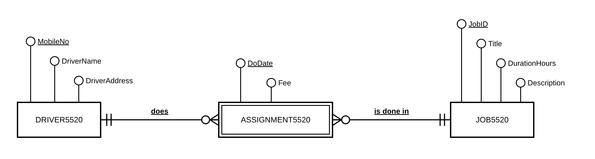
Figure 28: Entity Relationship Diagram (ERD) for SwinEats Food Delivery System.
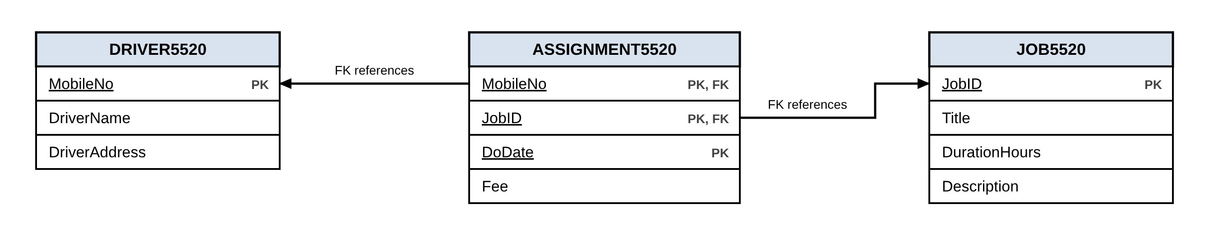
Figure 29: Entity Relationship Model (ERM) for SwinEats Food Delivery System.
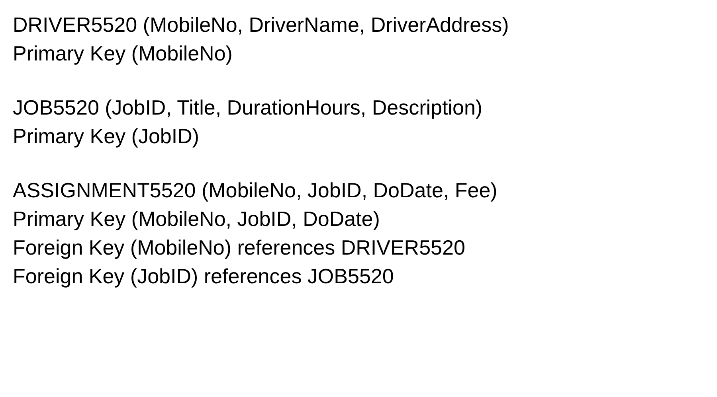

From my perspective, the many-to-many relationship between drivers and jobs should be resolved by creating the weak entity ASSIGNMENT5520, which links DRIVER5520 and JOB5520 through two one-to-many relationships. Furthermore, ASSIGNMENT5520 borrows the identifiers MobileNo and JobID from its parent entities, and these become foreign keys in the relational schema. Consequently, its primary key is the composite (MobileNo, JobID, DoDate), because a single date alone cannot uniquely identify an assignment; for instance, different drivers can complete different jobs on the same day.
Figure 30: Relational Schema for SwinEats Food Delivery System.
First and foremost, I created the above tables in the iSQL Junior website, then in Microsoft Access and .txt files in order to establish the relational database schema, test primary and foreign key constraints, and facilitate data migration.
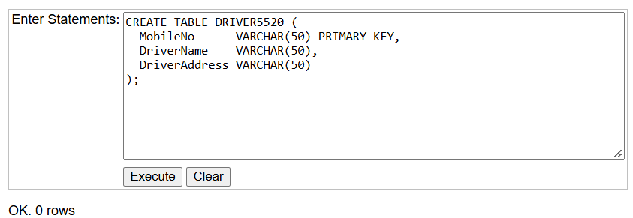
Figure 31: Execution of DDL Statement for DRIVER5520 Table.
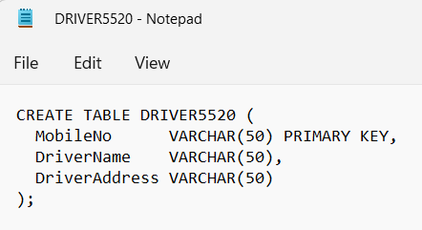
Figure 32: SQL Script File for DRIVER5520 Table Creation.
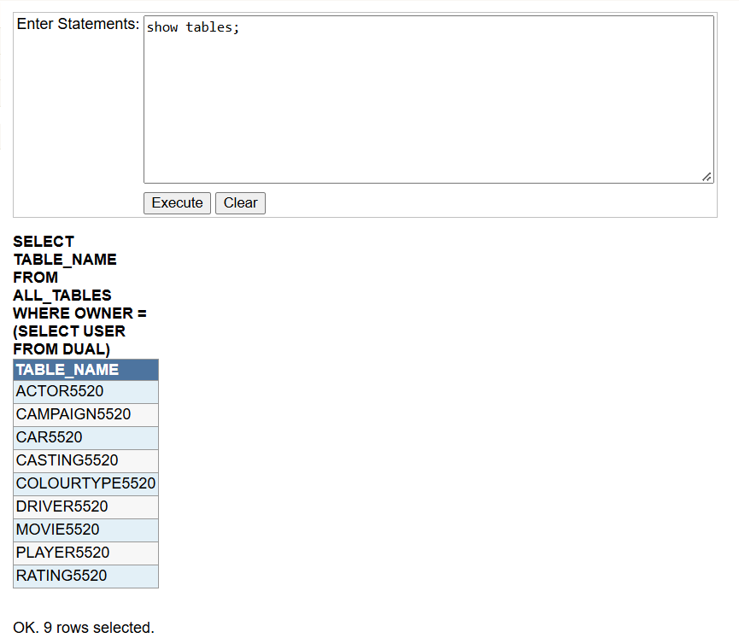
Figure 33: Verification of Existing Database Tables in iSQL Junior.
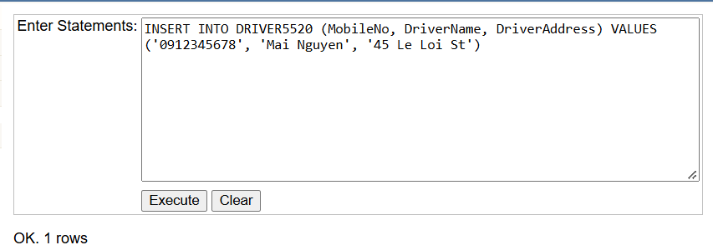
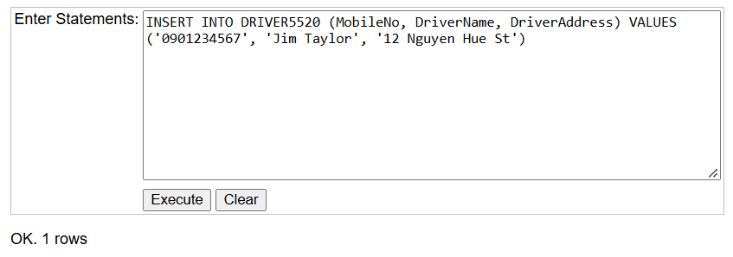
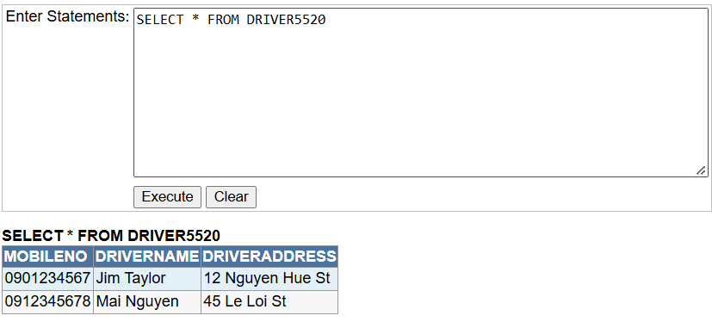
Figure 34: Inserting Test Data into DRIVER5520 Table.
Figure 35: Querying All Records from DRIVER5520 Table.
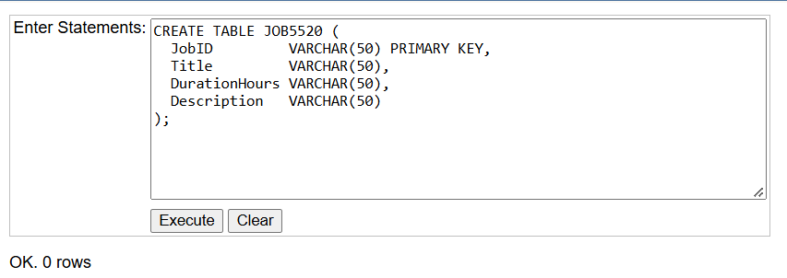
Figure 36: Creation of JOB5520 Table in iSQL Junior.
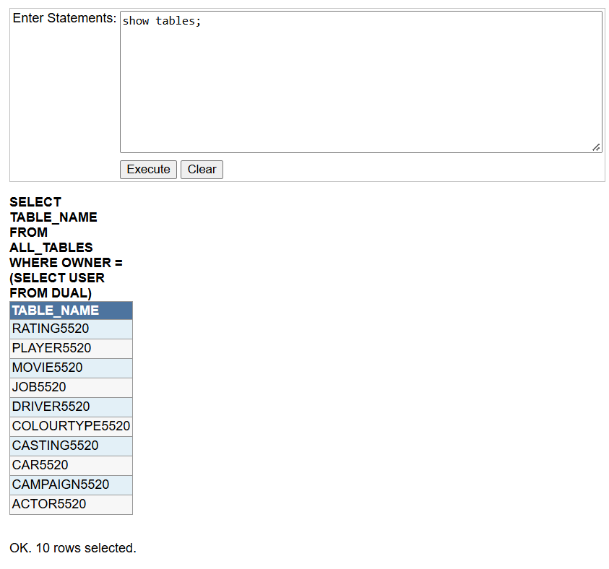
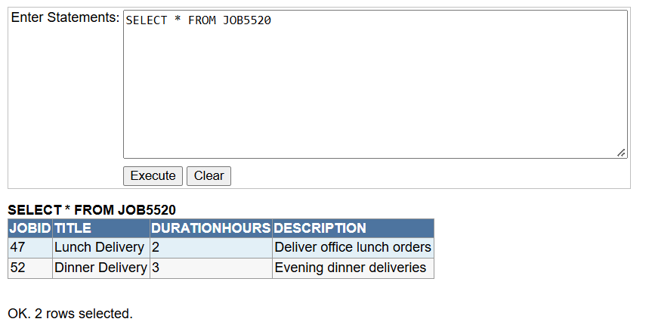
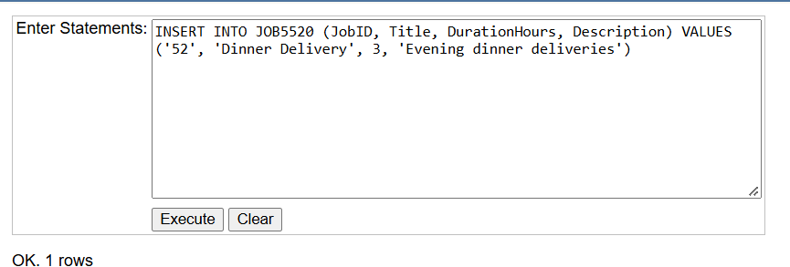
Figure 37: Verification of Updated Table List Including JOB5520.
.
Figure 39: Querying All Records from JOB5520 Table.
Figure 38: Executing Insert Statement for JOB5520 in iSQL Junior.
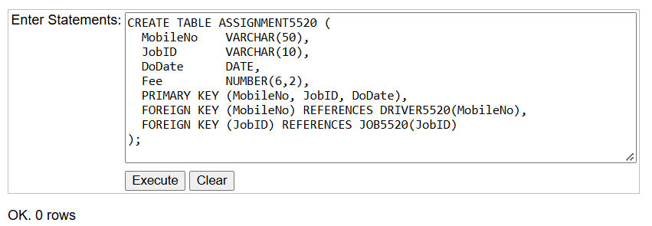
Figure 40: Creating ASSIGNMENT5520 Table with Primary and Foreign Keys in iSQL Junior.
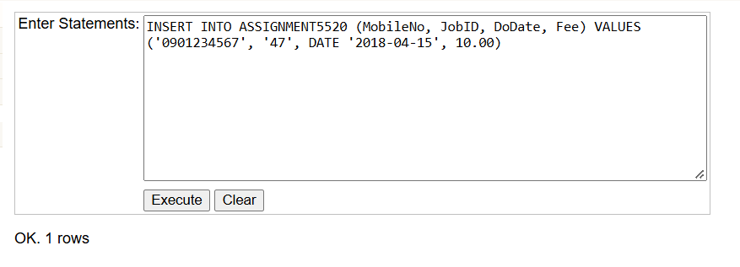
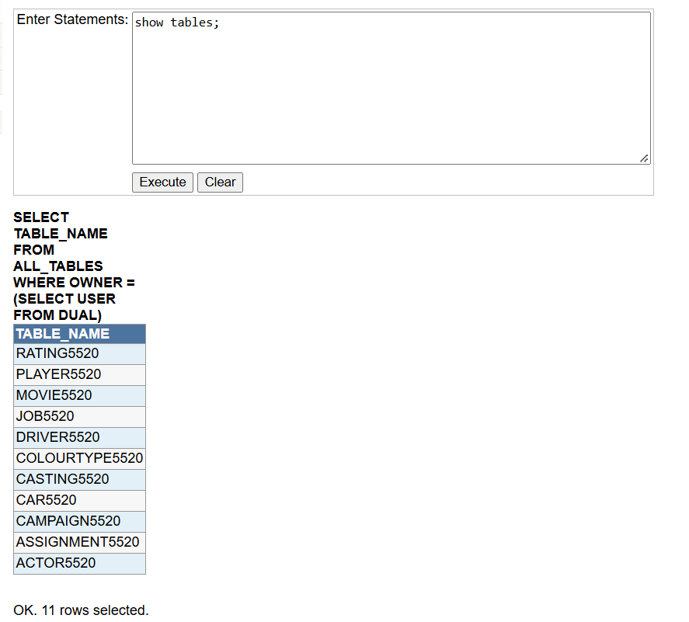
Figure 41: Verification of Final Table List Including ASSIGNMENT5520.
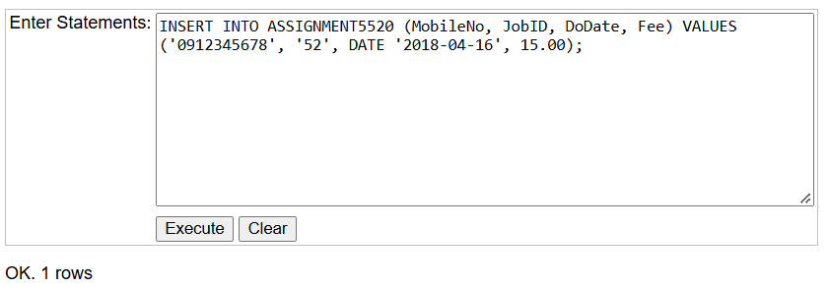
Figure 42: Executing Insert Statement for ASSIGNMENT5520 in iSQL Junior.
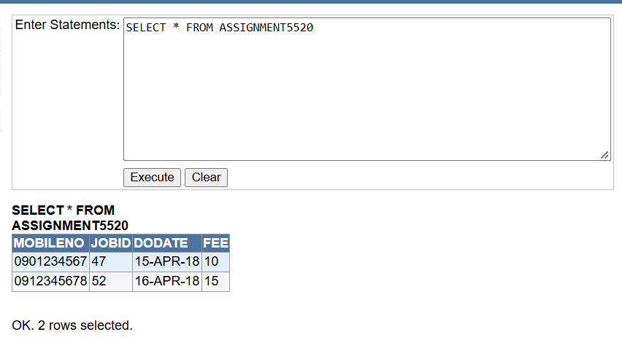
Figure 43: Querying All Records from ASSIGNMENT5520 Table.
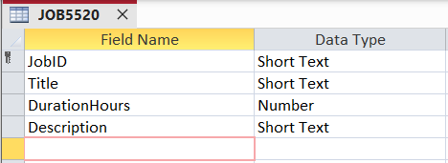
Figure 44: JOB5520 Table Design View in Microsoft Access.
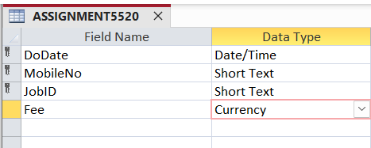
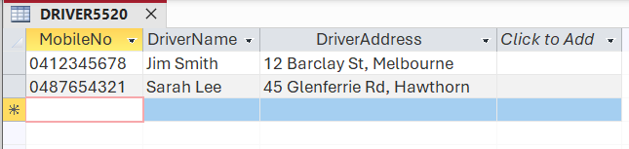
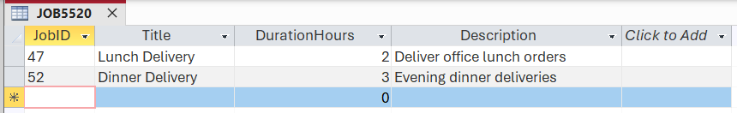
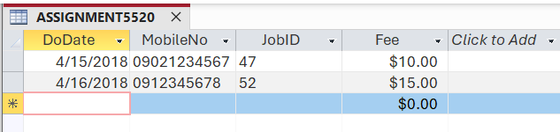
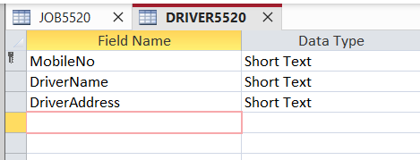
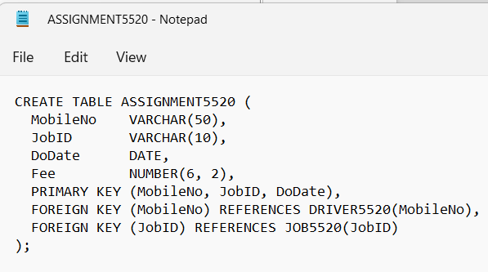
Figure 45: DRIVER5520 Table Design View in Microsoft Access.
Figure 50: SQL Script File for ASSIGNMENT5520 Table Creation.
Figure 49: ASSIGNMENT5520 Table Data Sheet View in Microsoft Access.
Figure 48: DRIVER5520 Table Data Sheet View in Microsoft Access.
Figure 47: JOB5520 Table Data Sheet View in Microsoft Access.
Figure 46: ASSIGNMENT5520 Table Design View in Microsoft Access.

Task Pass4k
Scenario: Hawthorn Comedy Inc. is planning to hold a festival made up of various comedy shows. Every show will have an ID, a title and a description. Each show is delivered by a comedian. Comedians have a name, an address, contact number, and email. One comedian may deliver more than one show at the festival. Members of the public will come and visit the festival as attendees. As each attendee enters the festival, their name, address and phone number will be recorded. Each attendee will be given a unique barcode id. During their visit, attendees will rate the show they see with a score of 1 to 10. This will be recorded by staff at Hawthorn Comedy Inc. Attendees will be able to vote for more than one show.

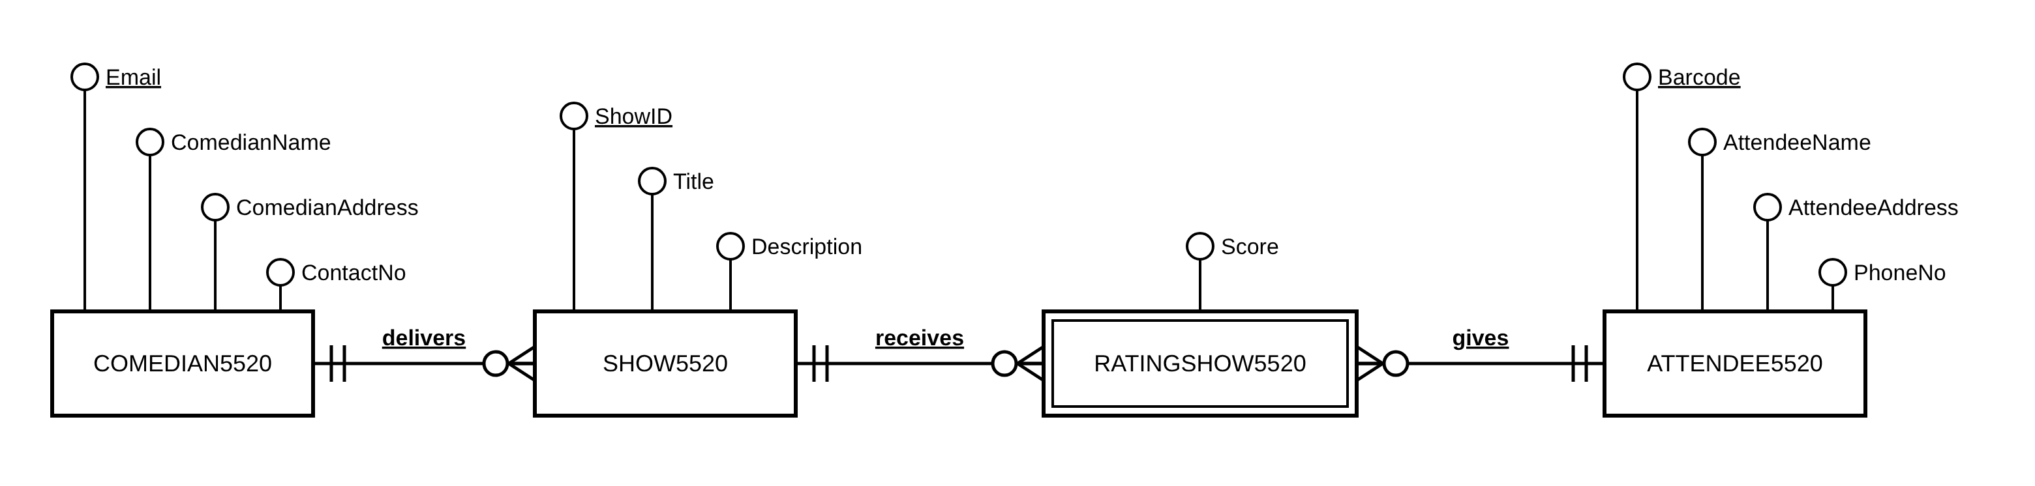
Figure 51: Entity Relationship Diagram (ERD) for Comedian, Show, Rating, and Attendee Entities.
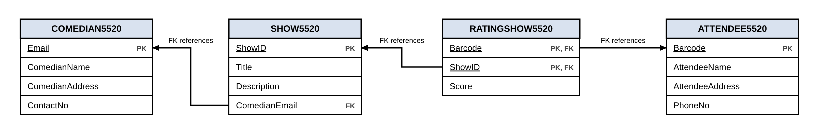
Figure 52: Entity Relationship Model (ERM) for Comedian, Show, Rating, and Attendee Entities.
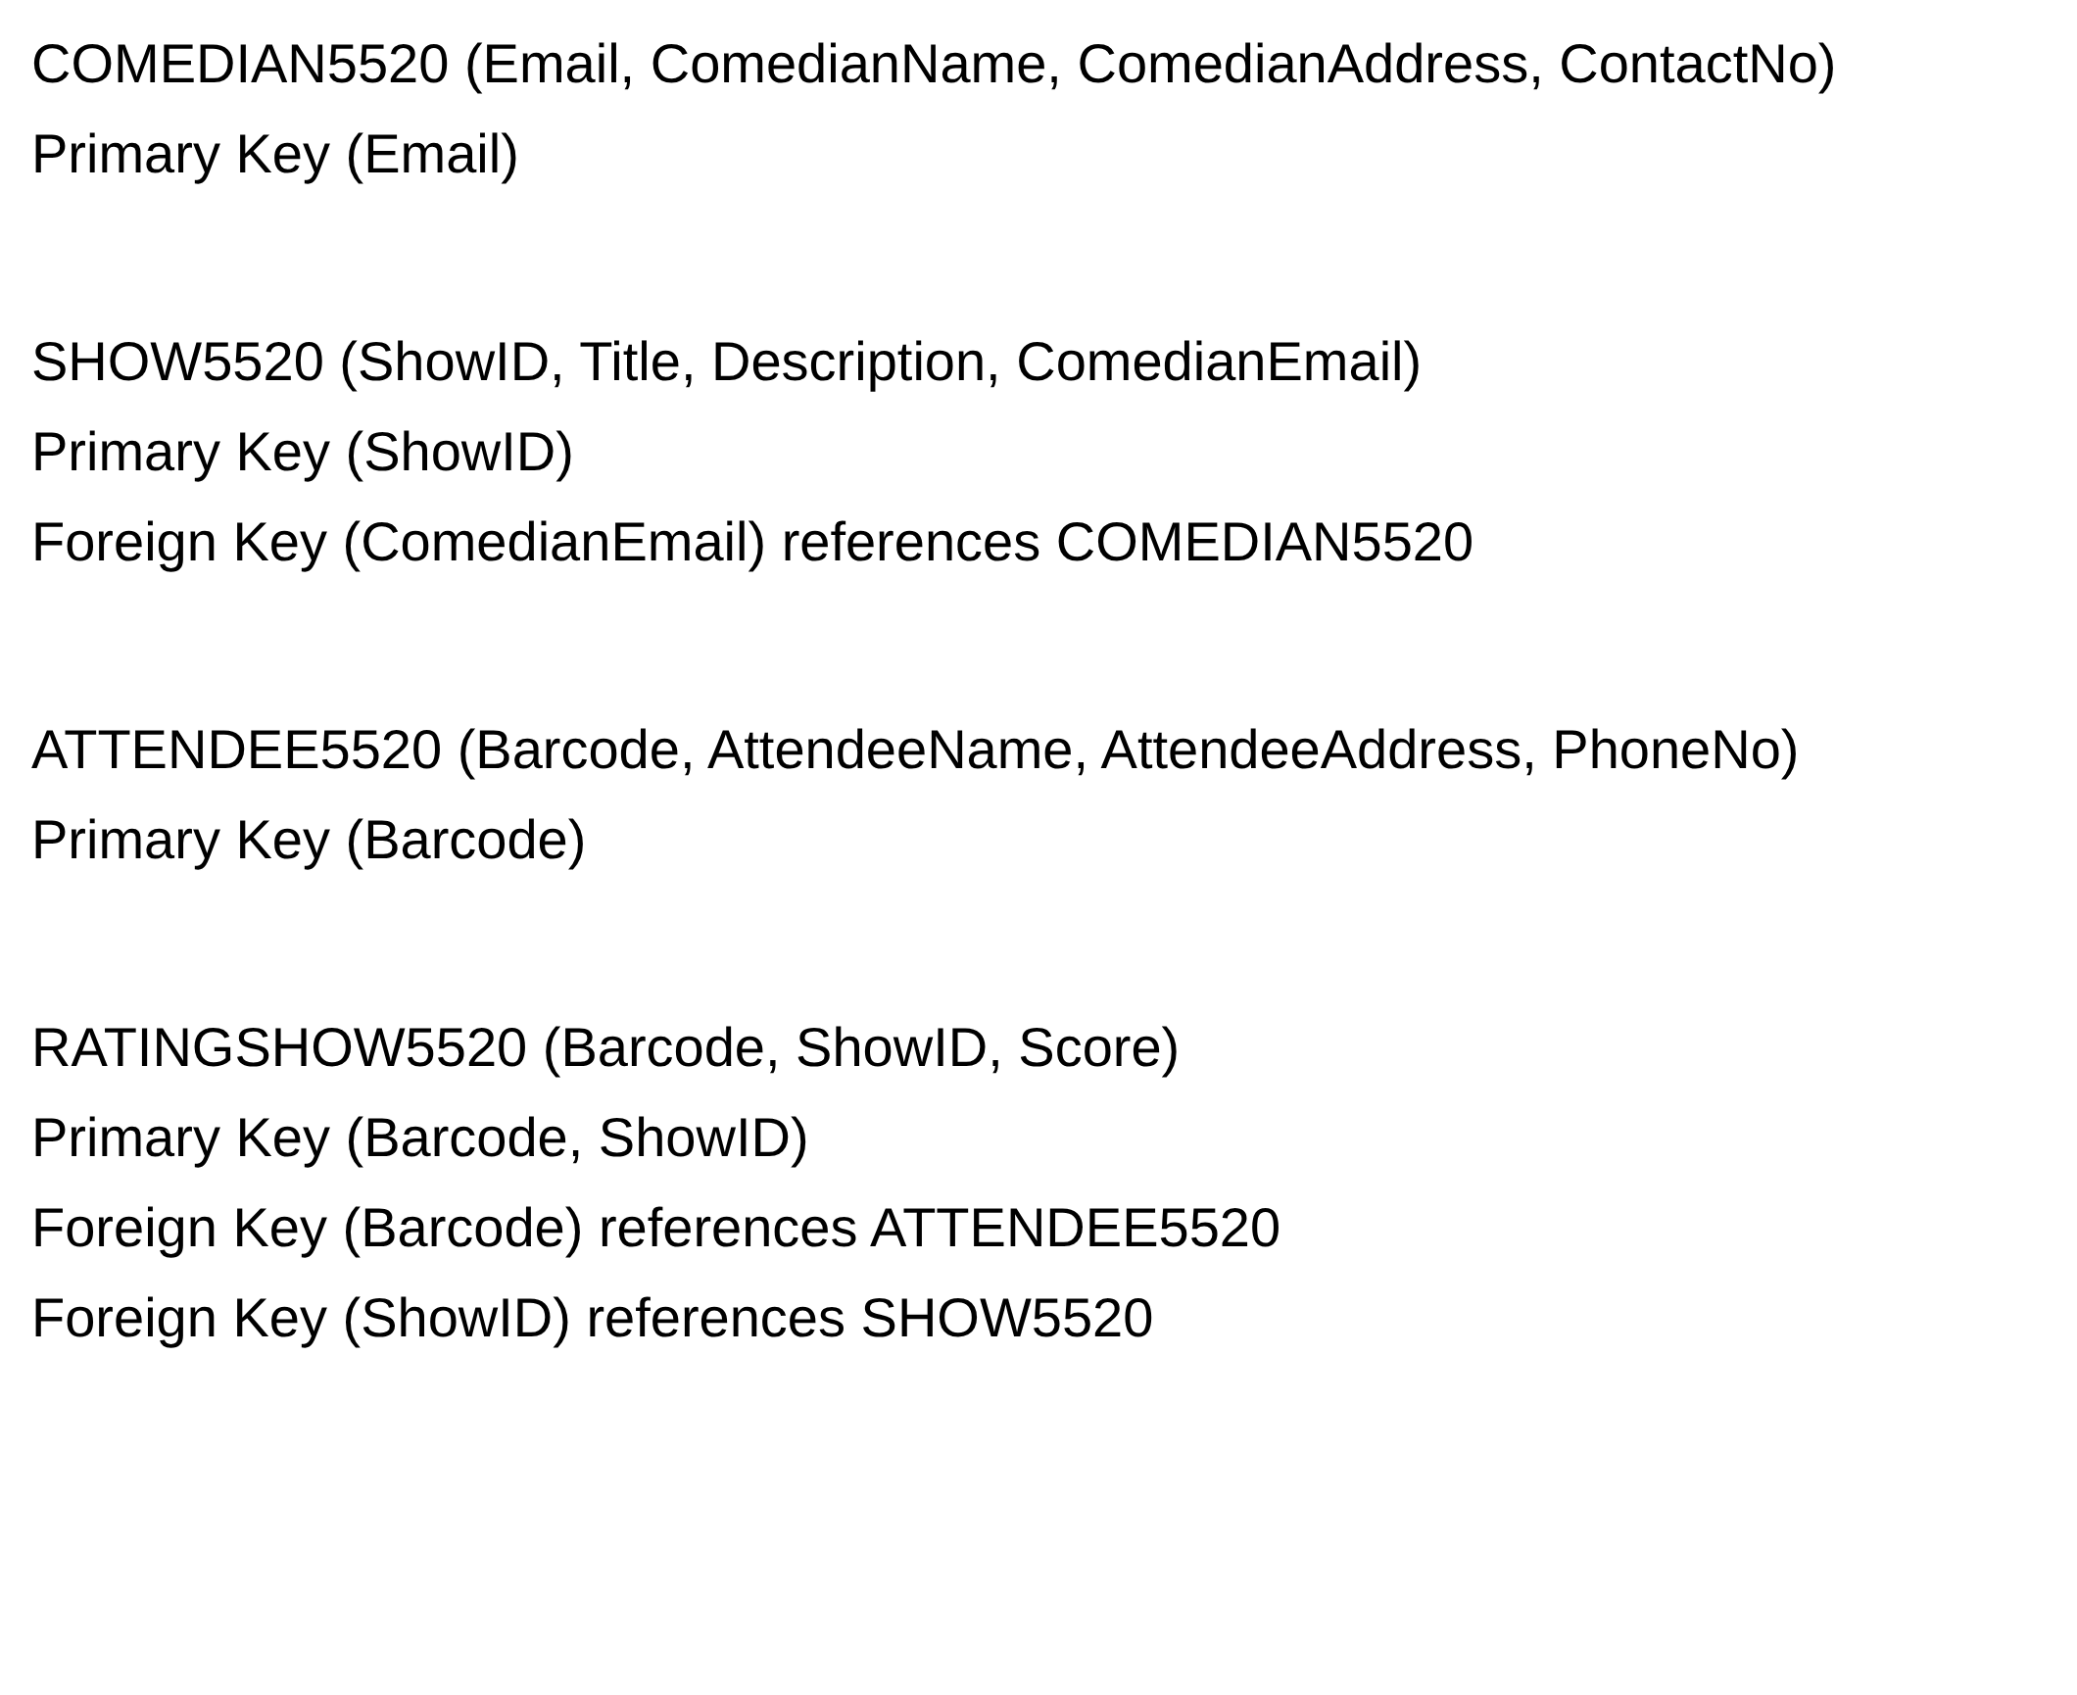
Figure 53: Relational Schema for Comedian, Show, Rating, and Attendee Entities.
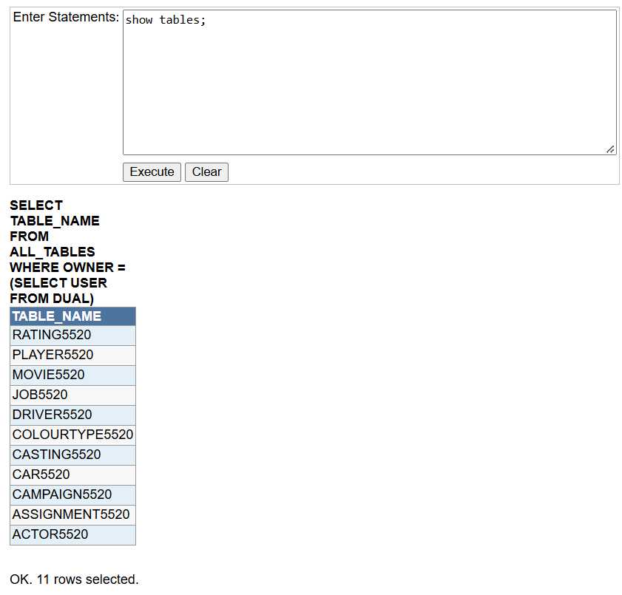
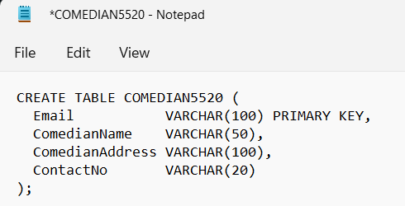
Figure 54: Verification of Existing Database Tables Before Creating the Pass 4k Tables in iSQL Junior.
Figure 55: SQL Script File Content for COMEDIAN5520 Schema.
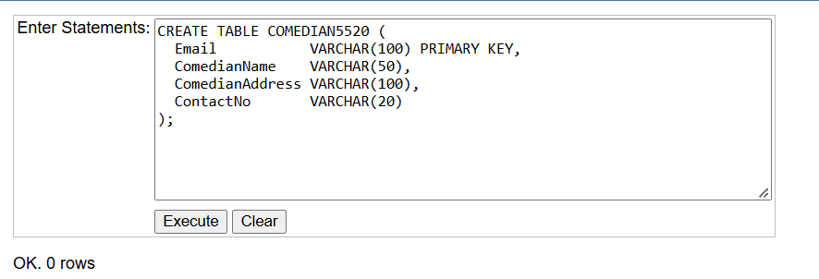
Figure 56: Creating COMEDIAN5520 Table in iSQL Junior.
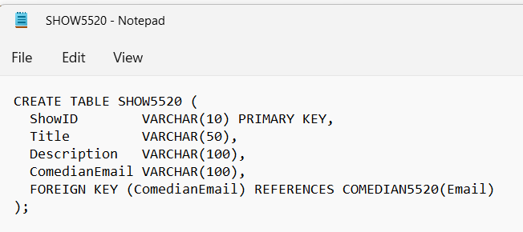
Figure 57: SQL Script File Content for SHOW5520 Schema.
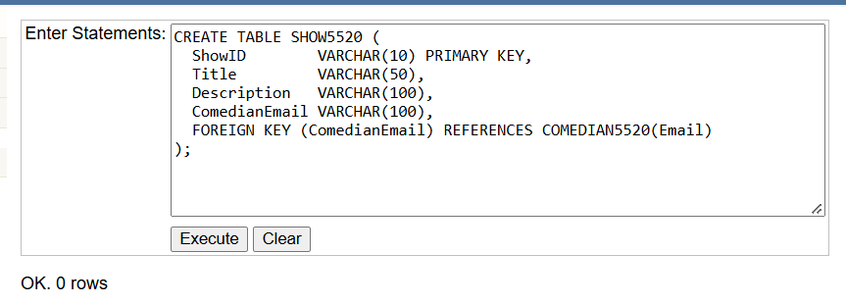
Figure 58: Creating SHOW5520 Table in iSQL Junior.
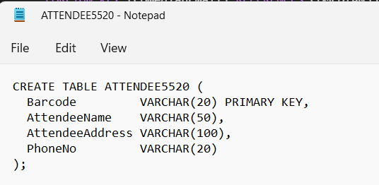
Figure 59: SQL Script File Content for ATTENDEE5520 Schema.
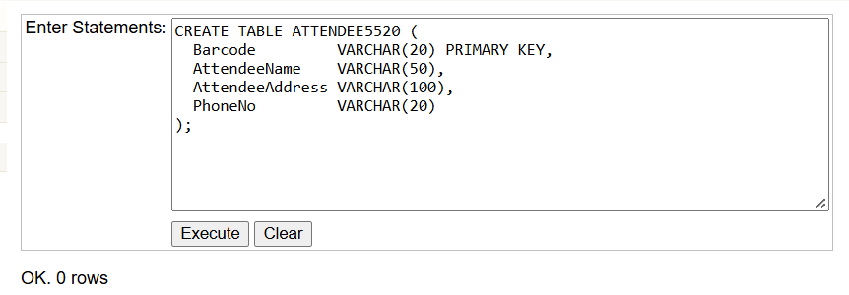
Figure 60: Creating ATTENDEE5520 Table in iSQL Junior.
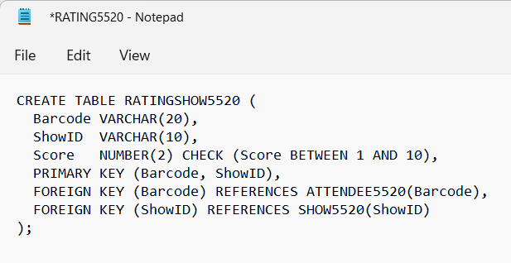
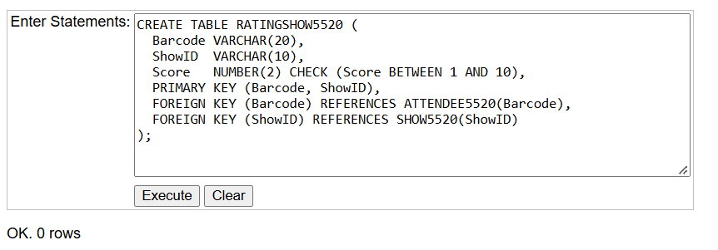
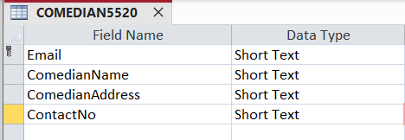
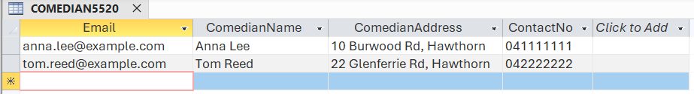
Figure 61: SQL Script File Content for RATINGSHOW5520 Schema.
Figure 62: Creating RATINGSHOW5520 Table in iSQL Junior.
Figure 63: COMEDIAN5520 Table Design View in Microsoft Access.
Figure 64: COMEDIAN5520 Table Datasheet View in Microsoft Access.
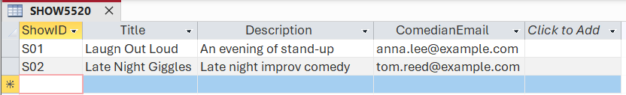
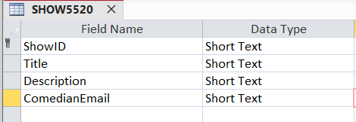
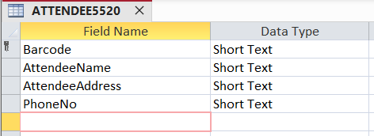
Figure 65: SHOW5520 Table Design View in Microsoft Access.
Figure 66: SHOW5520 Table Datasheet View in Microsoft Access.
Figure 67: ATTENDEE5520 Table Design View in Microsoft Access.
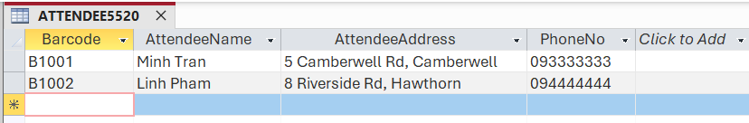
Figure 68: ATTENDEE5520 Table Datasheet View in Microsoft Access.
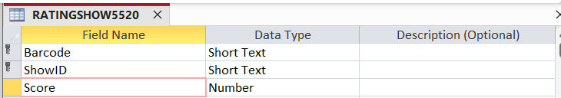
Figure 69: RATINGSHOW5520 Table Design View in Microsoft Access.
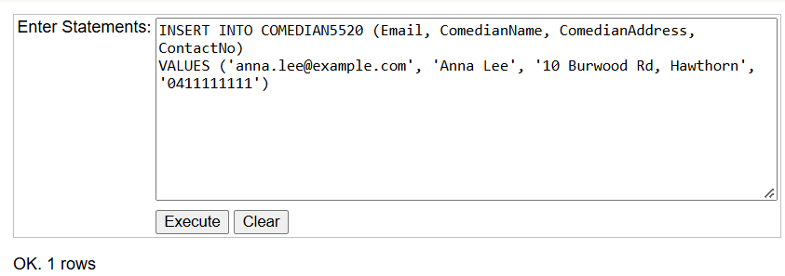
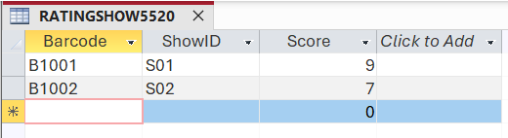
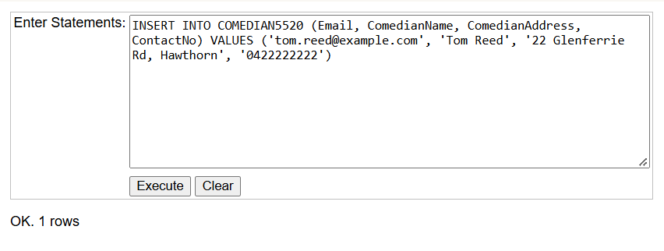
Figure 70: RATINGSHOW5520 Table Datasheet View in Microsoft Access.
Figure 71: Executing Insert Statement for COMEDIAN5520 Table.
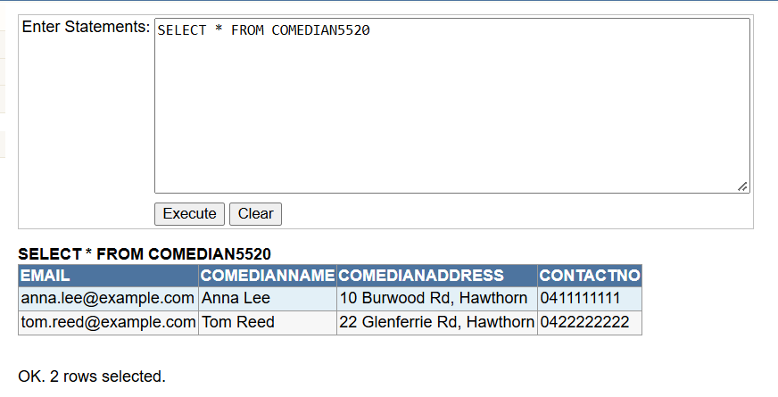
Figure 72: Querying All Records from COMEDIAN5520 Table.
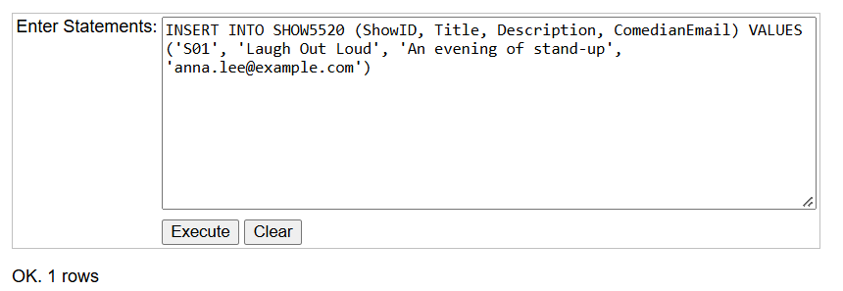
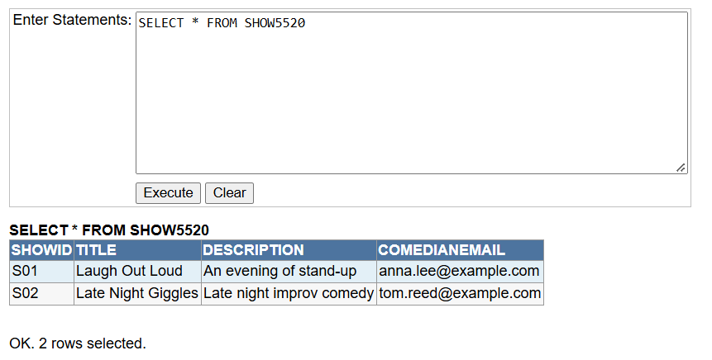
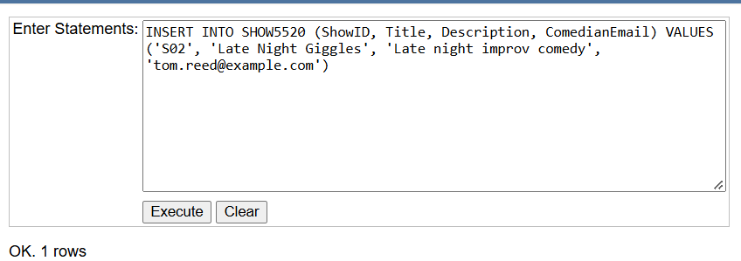
Figure 73: Executing Insert Statement for SHOW5520 Table.
Figure 74: Querying All Records from SHOW5520 Table.
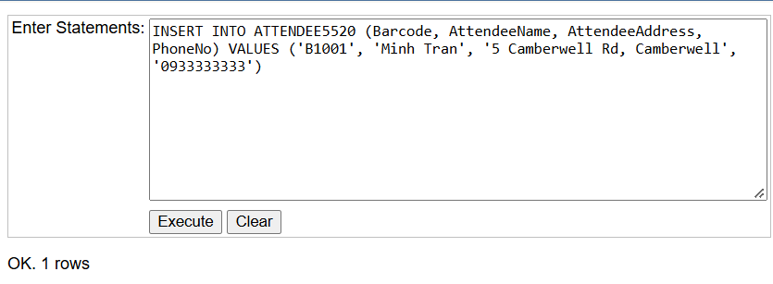
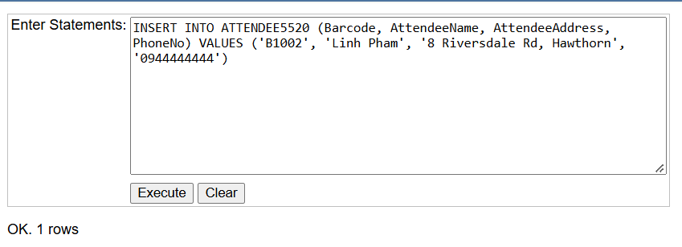
Figure 75: Executing Insert Statement for ATTENDEE5520 Table.
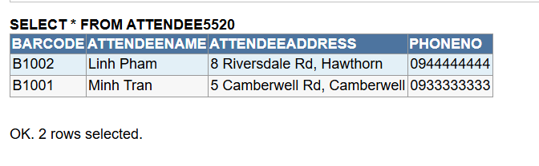
Figure 76: Querying All Records from ATTENDEE5520 Table.
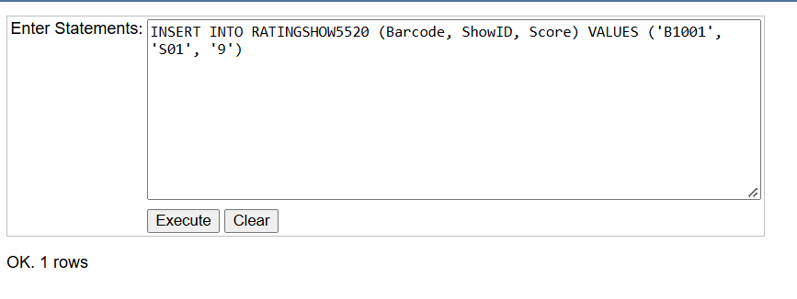
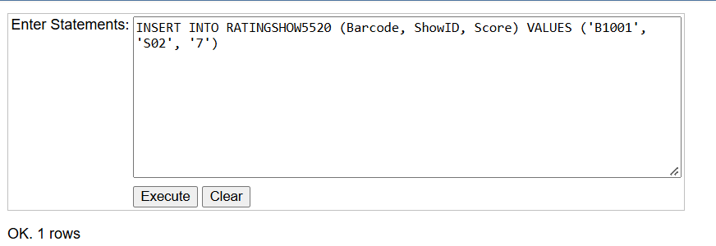
Figure 77: Executing Insert Statement for RATINGSHOW5520 Table.
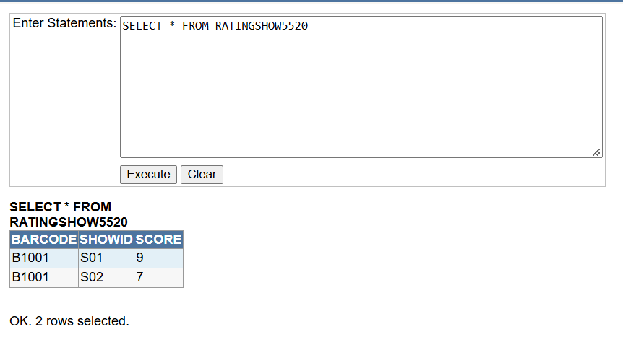
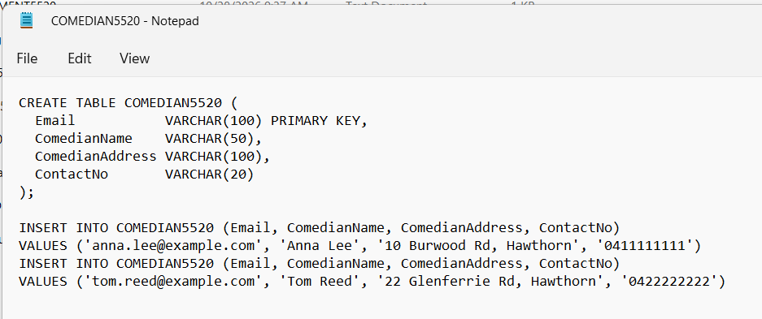
Figure 78: Querying All Records from RATINGSHOW5520 Table.
Figure 79: Script File Containing DDL and Insert Statements for COMEDIAN5520.
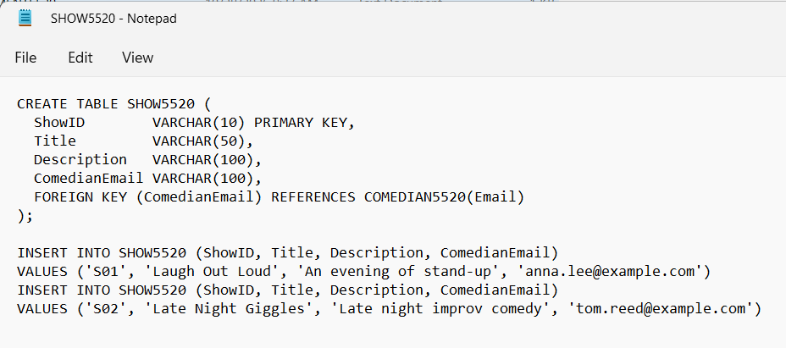
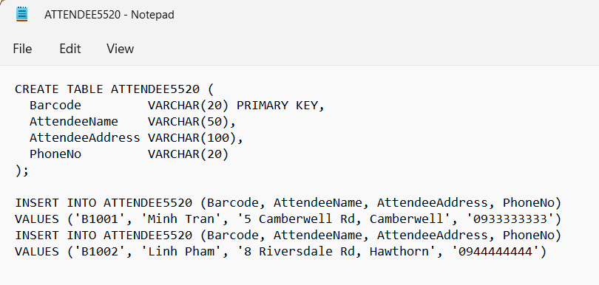
Figure 80: Script File Containing DDL and Insert Statements for SHOW5520.
Figure 81: Script File Containing DDL and Insert Statements for ATTENDEE5520.
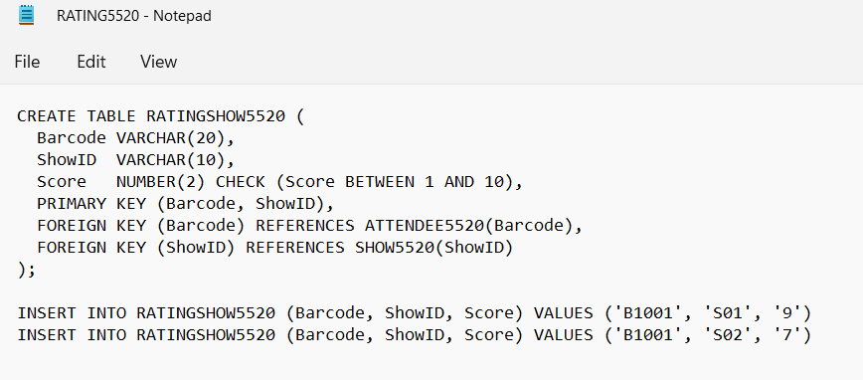
Figure 82: Script File Containing DDL and Insert Statements for RATINGSHOW5520.

Conclusion
From my perspective, Task 4 Pass strengthened my understanding of how an entity-relationship diagram is converted into a relational schema, particularly how one-to-many relationships create foreign keys and how many-to-many relationships are resolved through a weak entity with a composite primary key. Moreover, creating the tables in iSQL Junior and deliberately testing the primary key, foreign key and parent-child constraints showed me how a database enforces referential integrity in practice. Consequently, I became more confident in writing SQL statements, including joins, aggregate functions and the IN operator in Access, to retrieve meaningful information from related tables.

